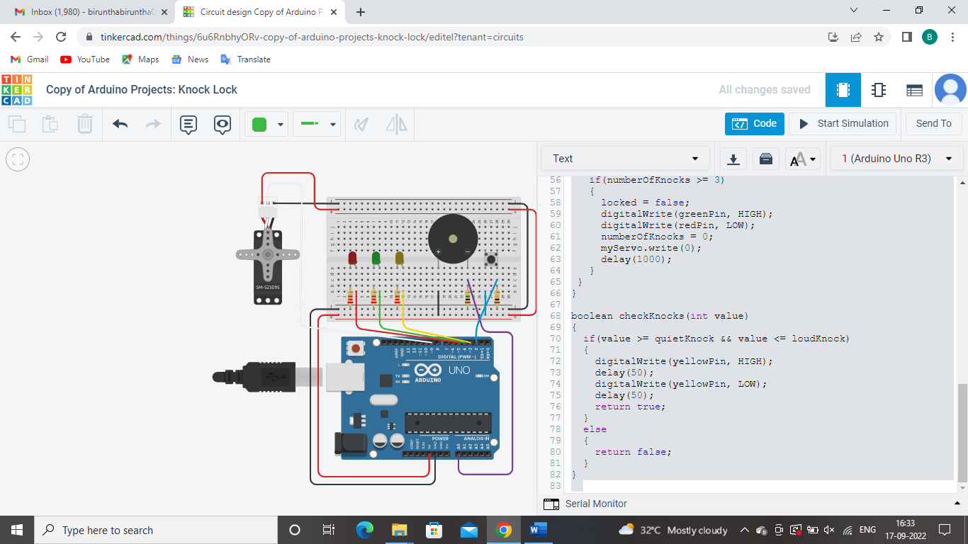

#include <Servo.h>

Servo myServo;

const int piezoPin = A0;

const int switchPin = 2;

const int servoPin = 9;

const int yellowPin = 3;

const int greenPin = 4;

const int redPin = 5;

int piezoVal;

int switchVal;

const int quietKnock = 10;

const int loudKnock = 100;

int numberOfKnocks = 0;

boolean locked = false;

void setup()

{

pinMode(switchPin, INPUT);

pinMode(yellowPin, OUTPUT);

pinMode(greenPin, OUTPUT);

pinMode(redPin, OUTPUT);

myServo.attach(servoPin);

digitalWrite(greenPin, HIGH);

myServo.write(0);

delay(1000);

}

void loop()

{

if(locked == false)

{

switchVal = digitalRead(switchPin);

if(switchVal == HIGH)

{

locked = true;

digitalWrite(greenPin, LOW);

digitalWrite(redPin, HIGH);

myServo.write(90);

delay(1000);

}

}

if(locked == true)

{

piezoVal = analogRead(piezoPin);

if(piezoVal > 0 && numberOfKnocks < 3)

{

if(checkKnocks(piezoVal) == true)

{

numberOfKnocks++;

}

}

if(numberOfKnocks >= 3)

{

locked = false;

digitalWrite(greenPin, HIGH);

digitalWrite(redPin, LOW);

numberOfKnocks = 0;

myServo.write(0);

delay(1000);

}

}

}

boolean checkKnocks(int value)

{

if(value >= quietKnock && value <= loudKnock)

{

digitalWrite(yellowPin, HIGH);

delay(50);

digitalWrite(yellowPin, LOW);

delay(50);

return true;

}

else

{

return false;

}

}